**HealthAI: Intelligent Healthcare Assistant Using IBM Granite**

|  |  |
| --- | --- |
| Date | 28 june 2025 |
| Team ID | LTVIP2025TMID34448 |
| Project Name | HealthAI: Intelligent Healthcare Assistant Using IBM Granite |
| Maximum Marks | 4 Marks |

### HealthAI: Intelligent Healthcare Assistant Using IBM Granite

**Solution Architecture:**

HealthAI is designed to serve as an intelligent healthcare assistant, using IBM Granite foundation models to bridge the gap between complex healthcare challenges and cutting-edge AI-driven solutions. The architecture of HealthAI is thoughtfully structured to deliver scalable, secure, and highly personalized healthcare interactions.

**Key Objectives of the Solution Architecture:**

* **Leverage AI to Enhance Healthcare Delivery:** Use IBM Granite's large language models to understand, process, and respond to patient queries, medical data, and healthcare provider inputs with contextual accuracy.
* **Define the Structural Blueprint:** Clearly describe the software's architecture, including components, data flow, behavior, and system interactions, to all relevant stakeholders.
* **Guide Feature Development:** Establish a phased roadmap that outlines core features such as voice-enabled patient interaction, symptom tracking, medication reminders, and EMR integration.
* **Specify Technical Requirements:** Document technical specifications, security protocols (e.g., HIPAA compliance), integration standards, and performance benchmarks to ensure consistent delivery of the solution.

**Example - Solution Architecture Diagram:**

(Placeholder for your custom HealthAI architecture diagram. Suggestion: show components such as Patient Interface, Granite LLM API, EMR Connector, Data Lake, Compliance & Security Layer, Analytics Dashboard, and Feedback Loop.)

**Figure 1: Architecture and data flow of a voice-based patient diary application**  
Reference: [*AWS Blog – Voice Applications in Clinical Research*](https://aws.amazon.com/blogs/industries/voice-applications-in-clinical-research-powered-by-ai-on-aws-part-1-architecture-and-design-considerations)

Note: The HealthAI system builds upon similar principles, using IBM Granite instead of AWS AI services to process clinical voice notes and patient interactions.

**Solution Architecture:**

Solution architecture is a complex process – with many sub-processes – that bridges the gap between business problems and technology solutions. Its goals are to:

* Find the best tech solution to solve existing business problems.
* Describe the structure, characteristics, behavior, and other aspects of the software to project stakeholders.
* Define features, development phases, and solution requirements.
* Provide specifications according to which the solution is defined, managed, and delivered.

**Example - Solution Architecture Diagram:**

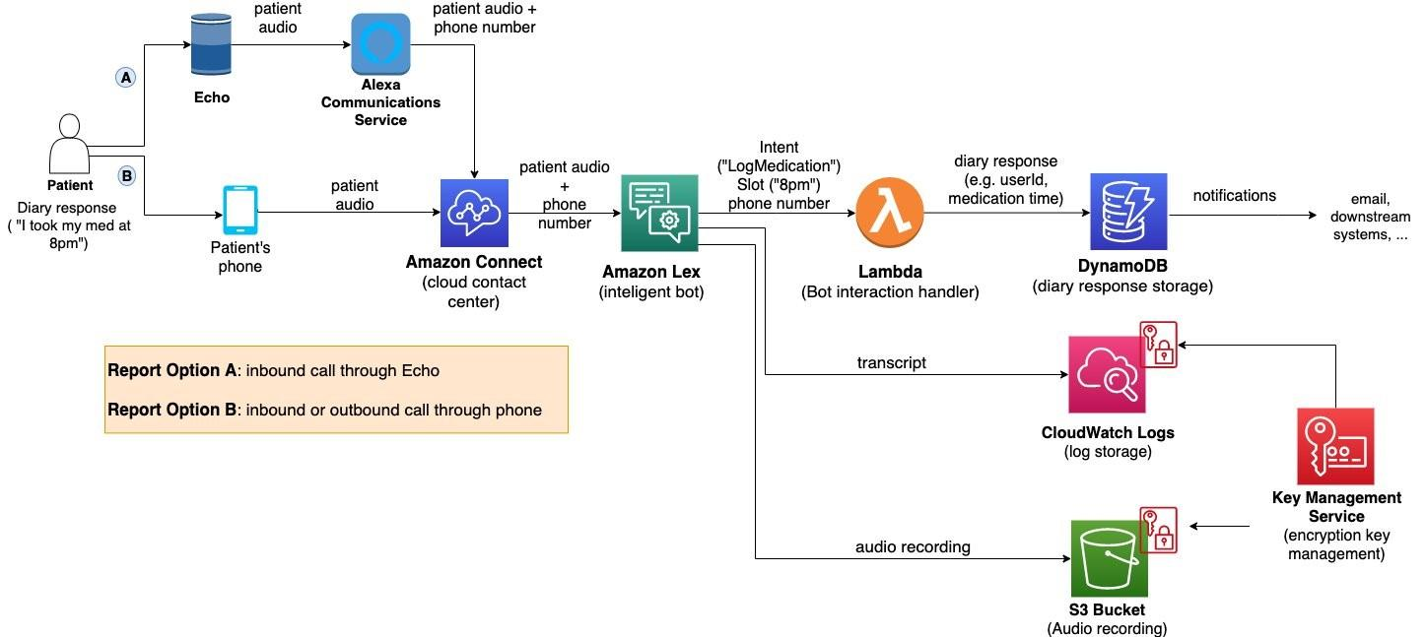

*Figure 1: Architecture and data flow of the voice patient diary sample application*

**Reference:** [**https://aws.amazon.com/blogs/industries/voice-applications-in-clinical-research-powered-by-ai-on-aws-part-1-architecture-and-design-considerations/**](https://aws.amazon.com/blogs/industries/voice-applications-in-clinical-research-powered-by-ai-on-aws-part-1-architecture-and-design-considerations/)